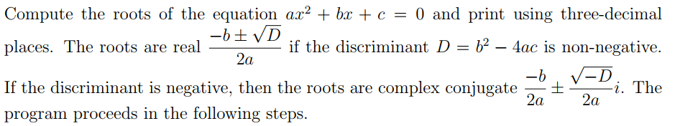

(a) It accepts the values of a; b and c from the keyboard.  
(b) No solution if both a and b are zero. The program finishes with appropriate message.  
(c) Linear equation if a = 0 but b ≠ 0 and the root is -c=b. The program prints out  
the root with appropriate message and the program finishes.  
(d) Calculates the discriminant D and determines the corresponding roots.  
(e) Prints out the roots with appropriate message and the program finishes.

Test data and expected output:  
Enter a,b,c: 0 2 3  
Linear equation: root = -1.500  
Enter a,b,c: 1 3 2  
The roots are real: -1.000 and -2.000  
Enter a,b,c: 2 6 9  
The roots are complex: -1.500+1.500i and -1.500-1.500i  
Enter a,b,c: 0 0 4  
No solution: a & b both zero